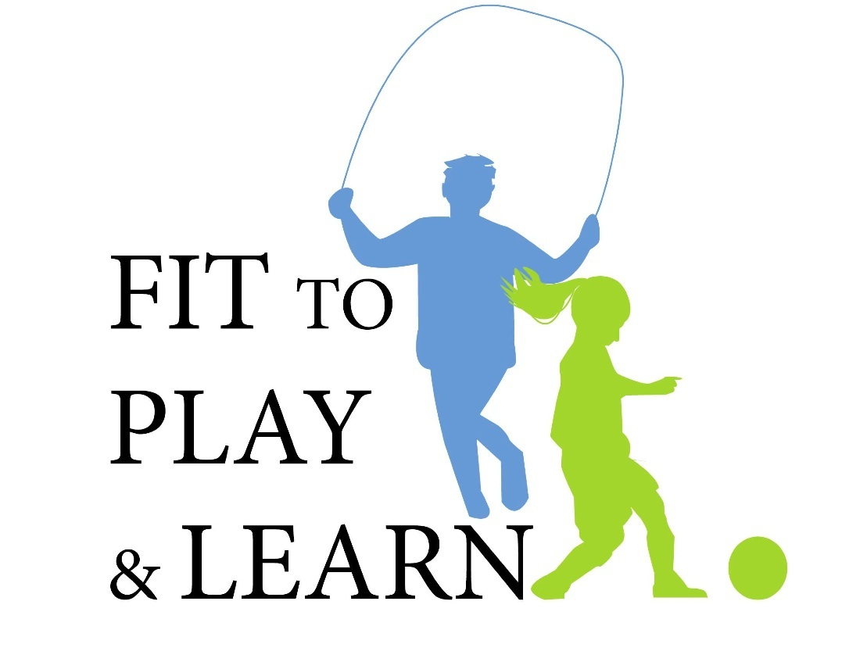

Healthy Eating Lesson Plan: To Augment and Reinforce Session 2
This lesson plan will focus on teaching the new food pyramid or plate and the concepts covered.
Half your plate should be fruits and vegetables.
Make half your grains whole.
Switch to fat-free or low fat milk.
Eat at least 5 fruits and vegetables a day.
Limit fats and oils. Choose healthy oils.
Homework – Students Recipes: Have students write down the recipe for one meal that their family makes that meet the “eating healthy guidelines” above. Children should take the My Plate and Healthy Eating Handout home as a reference for the eating healthy guidelines. This assignment will help to reinforce these guidelines with parents and to have them assess which meals meet these criteria.
For example
Chicken with onion, tomatoes and carrots baked in oven with olive oil.
This is a healthy meal because:
-1/2 of the dinner plate is carrots, tomatoes and onions
-healthy fat - olive oil instead of butter
-healthy protein - chicken
-healthy preparation of meal baked not fried
In Class Cookbook - The Teacher can assemble all recipes into a “Healthy Recipes Class Cookbook” which could be photocopied double-sided and given to students to give to parents as a Holiday gift, or Mother’s Day gift. Students could each make their own personalized cover, which could be stapled on to each child’s copy.

